Assignment-1

You will explore data, create visualizations, and design a dashboard on Tableau Public (if not Tableau Desktop). Then, you will include brief stories interactively you discover in the workbook. You can work with one or two classmates in a team when creating visualizations in worksheets, designing the dashboard and story points. You will submit your own copy and will write your own essay.

Good news! This assignment can be completed in a team of 2-3 students -if not individual-, and the team can submit only one copy to myCourses (except for teaming-up instruction if you don’t have any team yet.)

1. **Obtain a data set from airbnb**

Browse the datasets and descriptions at <http://insideairbnb.com/get-the-data/>. Choose a city in your interest, download the related datasets (one data set suffices, however, feel free to use multiple to merge for practice) and explore it with the graphical tools in Tableau Public.

1. **Explore**

You need to know the contextual information behind data. Do some readings on the city regarding the dataset.

On the web, you will see data resources to start reading: Data Policies, Data Assumptions are good to visit as below:

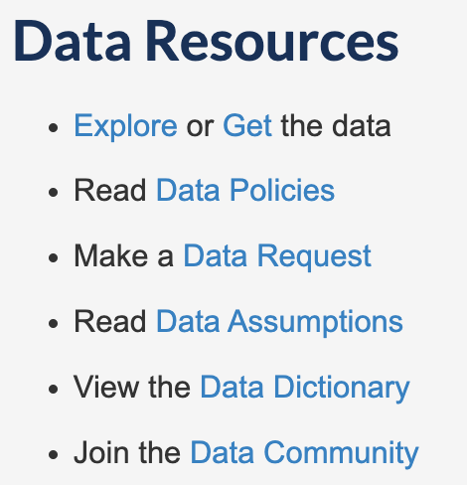

Think of some interesting relations you want to explore:

* What variables are you interested in?
* Will you need created/calculated measures?
* Explore interesting multivariate relations
* Just focus on these for now and start the exploration.

1. **Create interactive visualizations (30pts)**

Create four **interactive** visualizations in worksheets (each one is in one worksheet) by using the appropriate charts and the features you practiced in the nine videos. Do not necessarily use the same selection of visualizations in the training but rather identify those appropriate to your data.

1. **Create an interactive dashboard,** so that it is possible for the user to explore the data from different perspectives. (10pts)
2. **Create a series of story points (10pts)**

Create a series of story points (at least two) in regards to the visualizations created on the dashboard, allowing the user to follow the narrative of discovery you’ve constructed through your visualizations and dashboard. See the below showing **two story points** (that are created with Blank new story points after creating New Story, then drag the visualizations or dashboards created on it) which can be interacted like a slide show with the user. Just play.

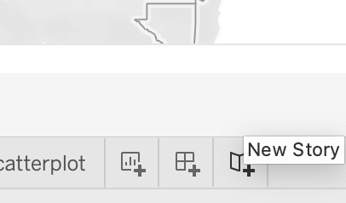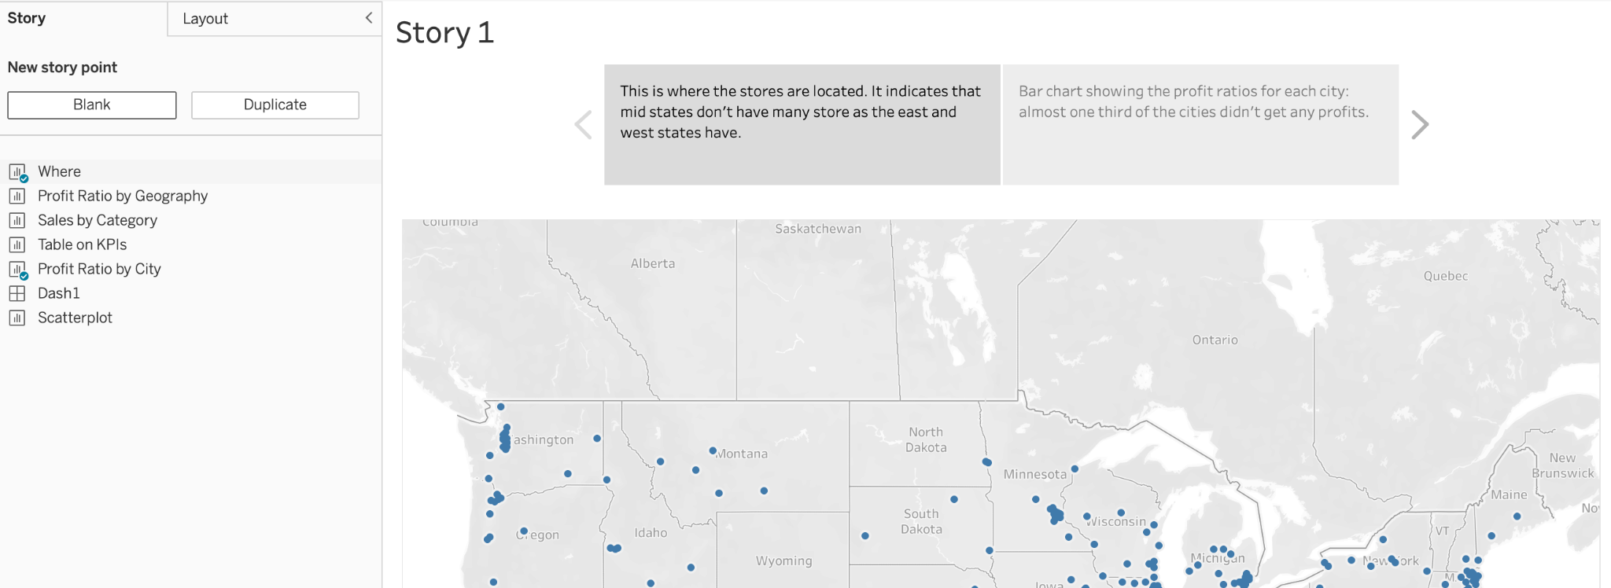

1. **Save and pack**

The packaged Tableau workbook has the extension of **.twbx (not the other extension)**. This keeps the dataset. Save the workbook in .twbx. Give it a filename of {your_first_name}_{city_name}.twbx. Then export your own copy as a -full- packaged workbook, which includes the data set so you will not need to attach the data separately with it.

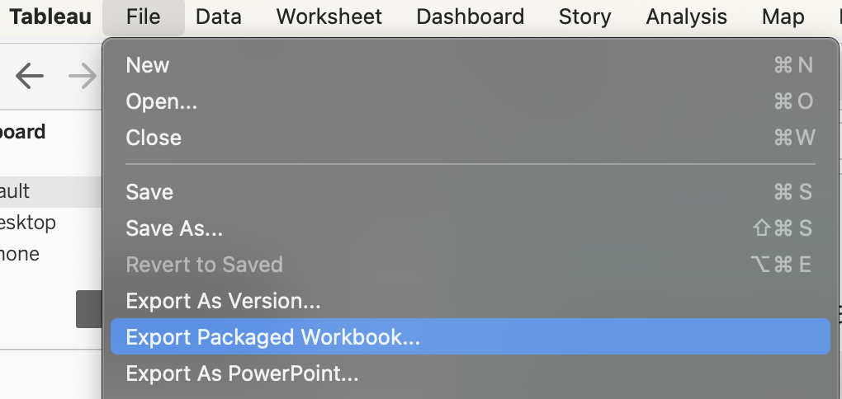

Did you work in a team? It is strongly encouraged. Include **teammate names** in the submission.

1. **Publish** and **Submit**

Publish your work on the Tableau Public. Don’t rush to create an online account on Tableau Online yet (it expires in 2-weeks, but we need this time interval for the next Python Integration Assignment)).

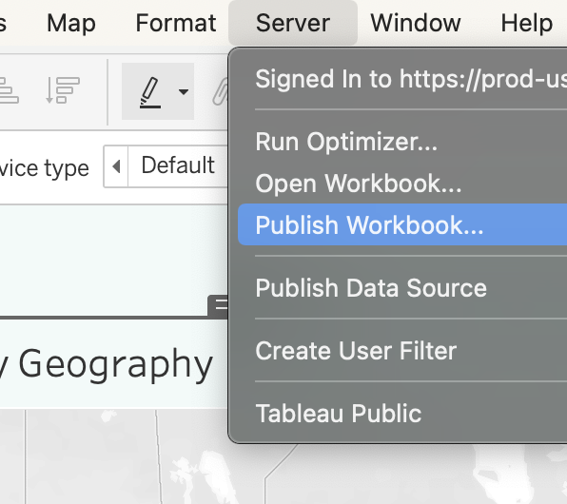

**Submission details** on myCourses**. 1) Submit** the published workbook weblink, 2) **Submit** two nice screenshots of your work (showing the best parts), **3) Include** team members (actually, only one submission per team through myCourses once i set up teaming-up on Week-3), **4) Write and Submit Tableau Design Essay** as described below, and **5)** **Keep** a copy of the packaged workbook file, named i.twbx, on your own drive (don’t attach any workbook!) so we will revisit it for **Python Integration**.

1. **Write Tableau Design Essay**

Answer the three discussion questions in an essay and attach to myCourses in a pdf file.

* 1. *Tableau makes a lot of default choices. Different chart types are recommended for different types of data. How would you determine and characterize these chart types recommended? Explain. Also, do you follow any guidelines, theories or use just Show Me? Make critiques.*
  2. *What is a data visualization? Make your own definition.*
  3. *In your opinion, what are the components or criteria of building effective and impactful interactive visualization for an average user? List them and give brief explanations. Does Tableau satisfy your components or criteria? Then, did you find any literature that discusses these components or criteria? You can refer to the papers we cover.*

I welcome collaborative work: teams can work together on this assignment (Tableau server/online allows collaboration features on the web). However, you will need to do **individual essay writing**. Just include team members when submitting whenever you work with any member.

1. **Evaluation**

Essay will be evaluated with the essay rubric. Your visualization design (in the story points) will be evaluated based on whether it reflects the practices in the nine videos and follows the instructions here.

**More Tableau Resources:**

* Tableau help - <https://help.tableau.com/current/pro/desktop/en-us/default.htm>
* Merging/joining multi data sets - <https://help.tableau.com/current/pro/desktop/en-us/joining_tables.htm>
* More about Tableau - <https://www.tableau.com/support/help>